Software Requirements Specification

For

Online Lunch Registration System

Table of Contents

1. Introduction 1

1.1 Purpose 1

1.2 Document Conventions 1

1.3 Intended Audience and Reading Suggestions 1

1.4 Product Scope 1

1.5 References 1

2. Overall Description 2

2.1 Product Perspective 2

2.2 Product Functions 2

2.3 User Classes and Characteristics 2

2.4 Operating Environment 2

2.5 Design and Implementation Constraints 2

2.6 User Documentation 2

2.7 Assumptions and Dependencies 3

3. External Interface Requirements 3

3.1 User Interfaces 3

3.2 Hardware Interfaces 3

3.3 Software Interfaces 3

3.4 Communications Interfaces 3

4. System Features 4

4.1 System Feature 4

5. Other Nonfunctional Requirements 4

5.1 Performance Requirements 4

5.2 Safety Requirements 5

5.3 Security Requirements 5

5.4 Software Quality Attributes 5

5.5 Business Rules 5

6. Other Requirements 5

# 1. Introduction

## 1.1 Purpose

## This project is used for booking lunch coupons and availing them through a website or by a mobile application. It is designed to ease the lunch registration system team by making it easily accessible for users as well as admins through a variety of platforms. The main features includes registration for lunch/tea coupons, online payment mode, availing coupons through QR code, splitting coupons with friends.

## 1.2 Document Conventions

This document uses the following conventions.

QR - Quick Response

DBMS - DataBase Management System

ER - Entity Relationship

OTP - One Time Password

UI - User Interface

DAO - Data Access Object

**1.3 Intended Audience and Reading Suggestions**

This project is a prototype for the lunch registration system in an organization. Admins can have full access and control over user registration as well as coupon generation system. Users can easily book and redeem their coupons using a QR code via a mobile application or a web application.

**1.4 Product Scope**

The purpose is to simplify the lunch coupon booking registration process and users can easily book via both mobile or desktop web application. This application even uses an efficient database for managing multiple users with proper authentication. This web application is further extended to use for different food booking options online and it’s extremely user friendly UI makes it efficient and reliable.

**1.5 References**

Firebase Database Documentation: <https://firebase.google.com/docs>

Razorpay API Documentation: https://razorpay.com/docs

# 2. Overall Description

## Product Perspective

The Online Lunch Registration System contains the following features:

* Buying of Coupons:

Instead of buying the coupons booklet manually, students will be available to buy the coupons online with ease of variety of payment methods such as wallet payments, credit or debit cards.

* Lunch Registration:

Students will also be able to register for the lunch online, not only for themselves but they can share their coupons with friends, this will eliminate the need of maintaining a registry of students for lunch.

* Availing Lunch:

Availing the lunch will be made easy as the admin will just have to scan a QR Code of the students and it will decide whether they are registered for lunch or not. This will reduce the time, admin used to take for searching the students name in the registry.

## 2.2 Product Functions

The Online Lunch Registration System are shown below in entity–relationship model (ER model):

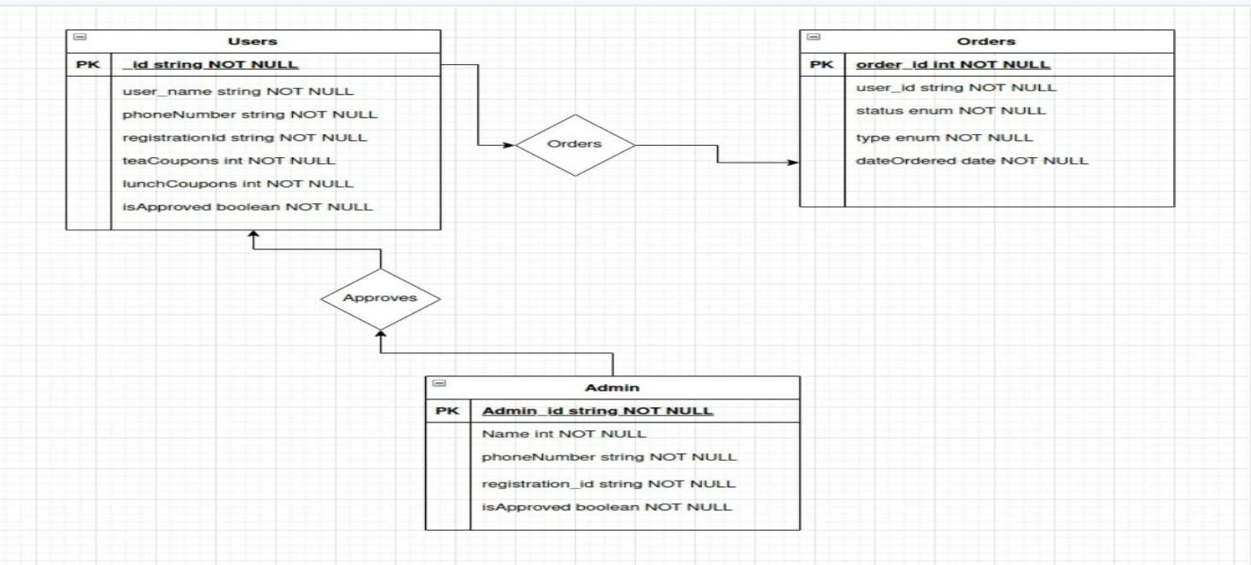

## User Classes and Characteristics

The User will be able to register for lunch online with much ease then before, he can buy the coupons monthly online and just register for the lunch for today/next day (depends on the time).

He can also share his/her coupons with his/her friends. The job of admins will be to scan the QR Code of the students while availing the lunch to see if he/she is registered for lunch or not. There will be two types of Coupons: Tea Coupons and Lunch Coupons. For Lunch, you have to register before 10 am (time may change) , but for tea you can avail it anytime , you just have to scan the QR code at the counter for availing the tea.

Authentication will work the following way:

* User logins using his mobile number (OTP will be sent).
* User send request to admin to approve him of buying coupons.
* Admin verifies the details of the student to see if he is authentic student.
* Admin approves the request.
* Student can start buying coupon and register for lunch.

## Operating Environment

Operating environment for the Online Lunch Registration System is as listed below.

* Android (React Native)
* Website (Angular UI ,Spring Backend)
* Database (NoSQL Document Based Cloud Firestore)
* Authentication (Firebase Auth)

## Assumptions and Dependencies

Following is the List of Assumptions:

* The Authentication will be made by the admin, and his verification will be not prone to any error.
* There will be good internet connection for the users to use the application efficiently.
* The admin at least has a knowledge with basic android apps usage.

# External Interface Requirements

This section gives description of Hardware ,Software ,Communication and a prototype of User Interface.

# 3.1 User Interfaces

* User interface of our application will be easy to use and understandable.
* Moreover,the user is expected to know how to use Android or IOS mobile devices or to use website

## 3.1.1 Login Interface

* A first-time user of the mobile application should see the log-in page when he/she opens the application, see Figure 1.
* If the user has not registered, he/she should be able to do that on the log-in page.

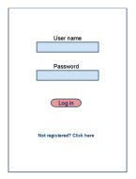

Figure 1.

## 3.1.2 Register Interface

* In this interface user register to the system by giving information of himself in a provided text field. There will be a button register.
* After user filled the required fields with his/her related information (username, password, gender etc.), click to the register button and be able to login the application.

## 3.1.3 Browser Interface

* The Student and administrators interact with the system through a web-portal, see Figure 2.
* A Student should be able to register on the web-portal in order to log in and manage the Coupons for lunch.
* An administrator should also be able to log in to the web-portal where he/she can administer and see total number of students registered for lunch.

## 

Figure 2.

## 3.1.4 Coupons Booking Interface

In this interface students can buy the coupons so that they can register for lunch and can share their coupons or they can register lunch for their friends.

## 3.2 Hardware Interfaces

1. This application works on Android ,IOS mobile devices and Tablets.
2. The website works on a browser which supports HTML,CSS and JavaScript.

## 3.3 Software Interfaces

Following are the software used in the project.

|  |  |  |
| --- | --- | --- |
| S.No | Software used | Description |
| 1 | Operating System | For Website, It is independent of OS and just required a browser which supports HTML and JS. For mobile application required Android or IOS. |
| 2 | Google Firebase | To store the student data , add or remove coupons we have use Firebase Database for DAO Layer. |
| 3 | Angular | To implement the project websites we have chosen angular for its more interactive support |
| 4 | React Native | To implement mobile application we have chosen React Native. |
| 5 | Spring boot | To implement Business logic i.e. service layer we have used spring boot. |

## 3.5 Communications Interfaces

The communication between the different parts of the system is important since they depend on each other. However, in what way the communication is achieved is not important for the system and is therefore handled by the underlying operating systems for both the mobile application and the web portal.

**4. System Features**

**4.1 Description and Priority**

* Online Lunch Registration System maintains information regarding
  + Student Details
  + Coupons Count
  + QR Information
  + Daily report of Students registered for lunch to Admin
* This project will save lots of time in terms of Students standing in queue to write the entry for lunch manually on lunch register book.
* Its provides a report on daily bases so maintains will be ease.

**4.2 Stimulus/Response Sequences**

* Registering for lunch will be at fingertips.
* On successful registration the link in the QR code will be updated.
* Student can keep trace of remaining lunch coupons.
* Sharing lunch coupons among students is add-on feature.

**4.3 Functional Requirements**

Other system features include:

**4.3.1 Distributed Database:**

* + Distributed database implies that a single application should be able do following
    - It has to operate transparently on data that is spread across a variety of databases.
    - And connected by a communication network.
  + Our applications use Firebase developed by google.
  + Firebase make a application high scalability and it is highly distributable.

**4.3.2Client/Server System**

* The term client/server refers primarily to an architecture or logical division of responsibilities.
* The client is the application (also known as the front-end), and the server is the DBMS (also known as the back-end).
* A client/server system is a distributed system in which
  + Some sites are client sites and others are server sites.
  + All the data resides at the server sites.
  + All applications execute at the client sites.

5. Other Nonfunctional Requirements

**5.1 Performance Requirements**

* The product shall be based on web and has to be run from a web server.
* The server shall be capable of supporting an arbitrary number of surface computers, tablets and displays, that is, it shall provide no limit on how many devices are in the system.
* The server shall be capable of supporting an arbitrary number of active customer payments, that is, no payments shall be lost under any circumstances.
  1. **Safety Requirements**
* Information transmission should be securely transmitted to server without any changes in information.
* The system shall log every state and state change of every action, and display to provision recovery from system failure.
* The system shall be capable of restoring itself to its previous state in the event of failure (e.g. a system crash or power loss).
  1. **Security Requirements**
* Security requirements ensure that the software is protected from unauthorized access to the system and its stored data. It also includes protection against viruses and malware attacks.
* The system shall able to use the app in different platforms like different versions of OS/Mobiles.
* The system shall able to do authentication process for login and payment.
  1. **Software Quality Attributes**
* AVAILABILITY: The system should be available at all times, meaning the user can access it using a web browser or mobile application. But food registration must be closed at 10 A.M.
* CORRECTNESS: The data of students who are registered for lunch must be sent to admin by 10.30 A.M.
* MAINTAINABILITY: The document should be easy for the users who execute the system day to day, for the developers who wish to edit or develop further, and for the personnel who is in charge of the maintenance.
* USABILITY: The GUI should be easy to learn and use by users of any technical background.
  1. **Business Rules**
* The online registration system shall include two types of accounts: the administrators and the students.
* To log in to the system mobile number is required and authenticated by the verification code (OTP) sent to that mobile number.
* The Application must be user friendly.